AI-Generated Visual Content Detection and Media Trust

Introduction
Generative AI is no longer limited to producing obviously artificial images. Newer image models can generate photorealistic scenes, readable text, and interface-like layouts. OpenAI’s GPT Image 2, for example, is documented as a current image model with the snapshot gpt-image-2-2026-04-21 (OpenAI, 2026a). This technical shift matters socially because online images are often treated as evidence. A screenshot of a livestream, a social media post, or a chat interface does not merely look like a picture; it appears to carry platform context, timestamps, comments, accounts, and other cues of authenticity.
This paper focuses on that changing status of visual evidence. Previous research has shown that people often struggle to distinguish AI-generated media from human-created or real media (Frank et al., 2024; Roca et al., 2025). Recent work also suggests that realistic AI-synthesized images can increase belief in misinformation when they seem to provide strong evidence for a claim (Guo et al., 2025), while AI-generated images are already being used by spammers and scammers on social platforms for audience growth (DiResta & Goldstein, 2024). At the same time, screenshots occupy a special position in online communication because they are frequently circulated as visual proof rather than as ordinary photographs (Inwood & Zappavigna, 2024).
This paper therefore asks a clearer research question: How accurately did university-level respondents distinguish AI-generated images from real images across common online visual categories, and how did their trust ratings differ by image source and category? To answer this question, the study uses a small-scale Wenjuanxing survey as its main local data source. Existing studies on synthetic media detection, misinformation, and visual evidence are used to frame and interpret the survey findings rather than to replace the local results.

Methods

Research Design
This study used a small-scale quantitative survey design. The Wenjuanxing survey provided the main local data for testing how university-level respondents judged AI-generated and real visual materials. Previous studies were used as background evidence because they explain why human detection of AI-generated images is difficult and why screenshot-like materials can influence credibility.
Four sources were used to guide the survey design and interpretation. Frank et al. (2024) and Roca et al. (2025) were used because they report human difficulty in detecting AI-generated media and images. Guo et al. (2025) was used because it connects realistic AI-generated images with misinformation credibility. Inwood and Zappavigna (2024) was used because it explains why screenshots often function as visual evidence in online communication.

Participants and Sample
Participants were recruited through convenience sampling and completed the survey online through Wenjuanxing. A total of 79 responses were collected. Ten responses failed the Q42 attention-check item, and three attention-check passers reported “high school or below” as their current education level. These responses were excluded from the main analysis so that the analytic sample matched the study’s university-level focus. The final analytic sample therefore included 66 valid university-level respondents.
Within this analytic sample, 26 respondents were first-year students, 14 were second-year students, 10 were third-year students, and 16 were fourth-year-or-above students or recent graduates. Most respondents used social media for at least one hour per day, and most had used AI tools either daily or weekly.

Materials
The survey used image-only materials. It contained eighteen visual items: nine AI-generated images and nine real images. The materials covered both ordinary photorealistic images and screenshot-like visual evidence. The five categories were text-bearing visual artifacts, portrait images, livestream commerce screenshots, food photographs, and virtual livestream or VTuber interface images. Each category contained matched AI-generated and real examples when possible.
The 18 items were selected purposively rather than randomly. Because the study focused on online visual credibility, the materials were chosen to cover five visual types that people commonly encounter on digital platforms. The set was also balanced by source, with nine AI-generated images and nine real images. Therefore, the materials should not be treated as a statistically representative sample of all online images; they were designed to compare responses across selected image categories. The participant-facing questionnaire did not reveal whether a file was AI-generated or real.

Measures
The survey included source-judgement items, trust-rating items, attitude items, one attention check, and one optional open-ended question. For each image, participants first judged its source on a five-point scale from “definitely real” to “definitely AI-generated.” They then rated how trustworthy the same image would seem if it appeared on social media or another online platform.
Detection accuracy was calculated as the proportion of correctly classified source-judgement items. For binary accuracy scoring, “definitely real” and “probably real” are counted as correct for real images, while “probably AI-generated” and “definitely AI-generated” are counted as correct for AI-generated images. “Unsure” was treated as incorrect or missing for the main accuracy score. Trust was measured through one five-point rating for each image. The attitude items measured general trust in online images and screenshots, the persuasive effect of interface elements, verification habits, and self-confidence in visual judgement. Q42 is an attention-check item requiring participants to select “completely disagree.”

Procedures
The survey had three sections. First, to describe the sample and control for relevant background differences, participants reported their year of study, daily social media use, AI tool use, and self-assessed ability to identify AI-generated or edited online images. Second, to measure source judgement before credibility judgement, participants completed the image task in two steps for each visual item. They first judged whether the image was real or AI-generated, and after that they rated how trustworthy the same image would seem if it appeared on social media or another online platform. Third, after finishing all image tasks, participants answered four media-trust attitude questions, one Q42 attention-check item, and one optional open-ended question about the cues they used.
No feedback was given during the task so that later answers would not be influenced by earlier corrections. Because the study compared responses across visual categories, the Wenjuanxing version grouped materials of the same type together. During analysis, responses that failed Q42 were flagged and excluded before detection accuracy and trust scores were calculated.

Results

Results from Existing Studies
The published studies reviewed for this project suggest three main patterns. First, human detection of AI-generated media remains unreliable even when participants know that some materials may be synthetic. Frank et al. (2024) and Roca et al. (2025) both show that visual detection is difficult across populations and image categories. This supports the assumption that students’ everyday visual judgement may not be enough to identify AI-generated images or screenshot-like materials consistently.
Second, realistic AI-generated images can affect how credible people find online information. Guo et al. (2025) found that AI-synthesized images can make false headlines more persuasive when the images appear to provide strong visual evidence. This is important for the current project because the survey does not only ask whether participants can classify images correctly; it also asks how trustworthy each image would seem on social media.
Third, screenshot-like materials deserve special attention. Inwood and Zappavigna (2024) argue that screenshots are often treated as visual evidence in online communication. For this project, that means livestream interfaces, platform-style screenshots, and text-bearing visual materials may create a stronger sense of authenticity than ordinary photographs, even when participants are uncertain about their source.

Survey Results
The Wenjuanxing survey collected 79 responses. Of these, 69 responses passed the Q42 attention-check item, giving an attention-check pass rate of 87.3%. Three attention-check passers reported “high school or below” as their education level and were excluded because the study focuses on university-level respondents. The final analytic sample therefore included 66 valid responses.
Table 1. Sample screening and final analytic sample
Screening step | Responses
Submitted responses | 79
Passed Q42 attention check | 69
Excluded for non-university-level education | 3
Final analytic sample | 66
Across all 18 image source-judgement items, the mean detection accuracy was 47.4%. Accuracy was higher for AI-generated images (52.9%) than for real images or screenshots (41.9%). This pattern suggests that respondents were not simply accepting all images as real. Instead, many real images were treated with suspicion and misclassified as AI-generated.
Table 2. Source-judgement accuracy by visual category
Image category | Accuracy
Text-bearing visual artifacts | 56.8%
Portrait images | 39.8%
Livestream commerce screenshots | 58.3%
Food photographs | 31.1%
Virtual livestream interfaces | 54.5%
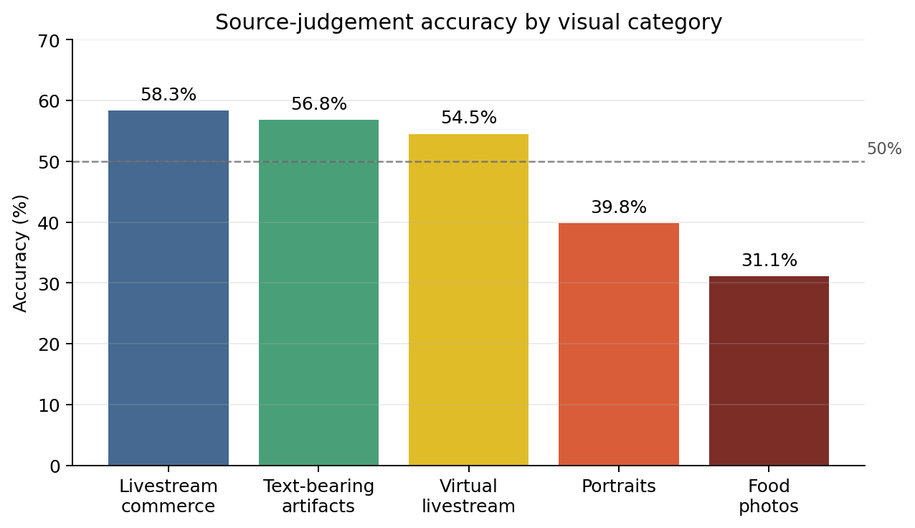
Figure 1. Source-judgement accuracy by visual category.
Category-level results show that livestream commerce screenshots and text-bearing visual artifacts produced the highest accuracy in this sample, while food photographs produced the lowest accuracy. The food-photo result is especially important because both real food images were frequently judged as AI-generated. This supports the broader claim that the spread of AI-generated images can create uncertainty not only about synthetic images, but also about real images that happen to look polished or artificial.
Trust ratings were measured on a five-point scale from 1 (“not trustworthy at all”) to 5 (“very trustworthy”). Real images received a slightly higher mean trust rating (M = 2.99) than AI-generated images (M = 2.70), but the difference was modest. By category, portrait images received the highest average trust rating (M = 3.14), followed by text-bearing visual artifacts (M = 2.98), virtual livestream interfaces (M = 2.73), livestream commerce screenshots (M = 2.70), and food photographs (M = 2.62).
The attitude items also show a cautious pattern of media trust. Respondents generally did not agree that online images and screenshots usually reflect reality (M = 2.39). At the same time, nearly half of the valid respondents agreed or strongly agreed that platform elements such as interfaces, comments, or livestream features can make screenshots more believable. Most respondents also reported verification habits: 42 out of 66 agreed or strongly agreed that they would look for sources or context when seeing realistic online images or screenshots. However, confidence in personal judgement was moderate to low (M = 2.83), with only 17 out of 66 agreeing or strongly agreeing that they were confident in judging whether online images were real.
The local survey results fit the broader pattern in the literature. Participants did not show stable or highly accurate source judgement; fewer than half of all image classifications were correct. AI-generated images were identified more accurately than real images, which suggests that the problem is not only the acceptance of fake images, but also the erosion of trust in real visual materials. Overall, the survey supports the paper’s main argument: as AI-generated images become more realistic, ordinary visual judgement becomes a fragile basis for deciding what online images and screenshots should be trusted.

References
Brundage, M., Avin, S., Clark, J., Toner, H., Eckersley, P., Garfinkel, B., Dafoe, A., Scharre, P., Zeitzoff, T., Filar, B., Anderson, H., Roff, H., Allen, G. C., Steinhardt, J., Flynn, C., Héigeartaigh, S. Ó., Beard, S., Belfield, H., Farquhar, S., … Amodei, D. (2018). The malicious use of artificial intelligence: Forecasting, prevention, and mitigation. Future of Humanity Institute. https://arxiv.org/abs/1802.07228
DiResta, R., & Goldstein, J. A. (2024). How spammers and scammers leverage AI-generated images on Facebook for audience growth. Harvard Kennedy School Misinformation Review. https://doi.org/10.37016/mr-2020-151
Frank, J., Herbert, F., Ricker, J., Schönherr, L., Eisenhofer, T., Fischer, A., Dürmuth, M., & Holz, T. (2024). A representative study on human detection of artificially generated media across countries. Proceedings of the 45th IEEE Symposium on Security and Privacy. https://arxiv.org/abs/2312.05976
Guo, S., Zhong, Y., & Hu, X. (2025). People are more susceptible to misinformation with realistic AI-synthesized images that provide strong evidence to headlines. Harvard Kennedy School Misinformation Review. https://doi.org/10.37016/mr-2020-189
Inwood, O., & Zappavigna, M. (2024). The legitimation of screenshots as visual evidence in social media: YouTube videos spreading misinformation and disinformation. Visual Communication. https://doi.org/10.1177/14703572241255664
Metzger, M. J., & Flanagin, A. J. (2013). Credibility and trust of information in online environments: The use of cognitive heuristics. Journal of Pragmatics, 59, 210-220. https://doi.org/10.1016/j.pragma.2013.07.012
Nightingale, S. J., & Farid, H. (2022). AI-synthesized faces are indistinguishable from real faces and more trustworthy. Proceedings of the National Academy of Sciences, 119(8), e2120481119. https://doi.org/10.1073/pnas.2120481119
OpenAI. (2026a). GPT Image 2 model. OpenAI API. https://developers.openai.com/api/docs/models/gpt-image-2
Pennycook, G., & Rand, D. G. (2021). The psychology of fake news. Trends in Cognitive Sciences, 25(5), 388-402. https://doi.org/10.1016/j.tics.2021.02.007
Roca, T., Cintron Roman, A., Torres Vega, J., Duarte, M., Wang, P., White, K., Misra, A., & Lavista Ferres, J. (2025). How good are humans at detecting AI-generated images? Learnings from an experiment. arXiv preprint. https://arxiv.org/abs/2507.18640
Vaccari, C., & Chadwick, A. (2020). Deepfakes and disinformation: Exploring the impact of synthetic political video on deception, uncertainty, and trust in news. Social Media + Society, 6(1). https://doi.org/10.1177/2056305120903408

